* **AI Interviewer Project Goals:**
* Local AI interviewer which automates job interviews
  + Parsing resume and job descriptions
  + Generate tailored interview questions
  + Conduct interview with an avatar with speech interaction
  + Monitor candidate behavior and generate evaluation
* **Part 1 - Parsing Resume and Job descriptions**
  + **Tools:** Ollama, PyMuPDF
  + PyMyPDF → extract text from the file
  + LLM summarizes candidate details ex: experiences and job requirements
* **Part 2 - Text-to-Speech with Whisper**
  + Whisper → speech recognition model
    - Multilingual speech recognition, translation, and language identification
    - Approach path of Whisper:
    - 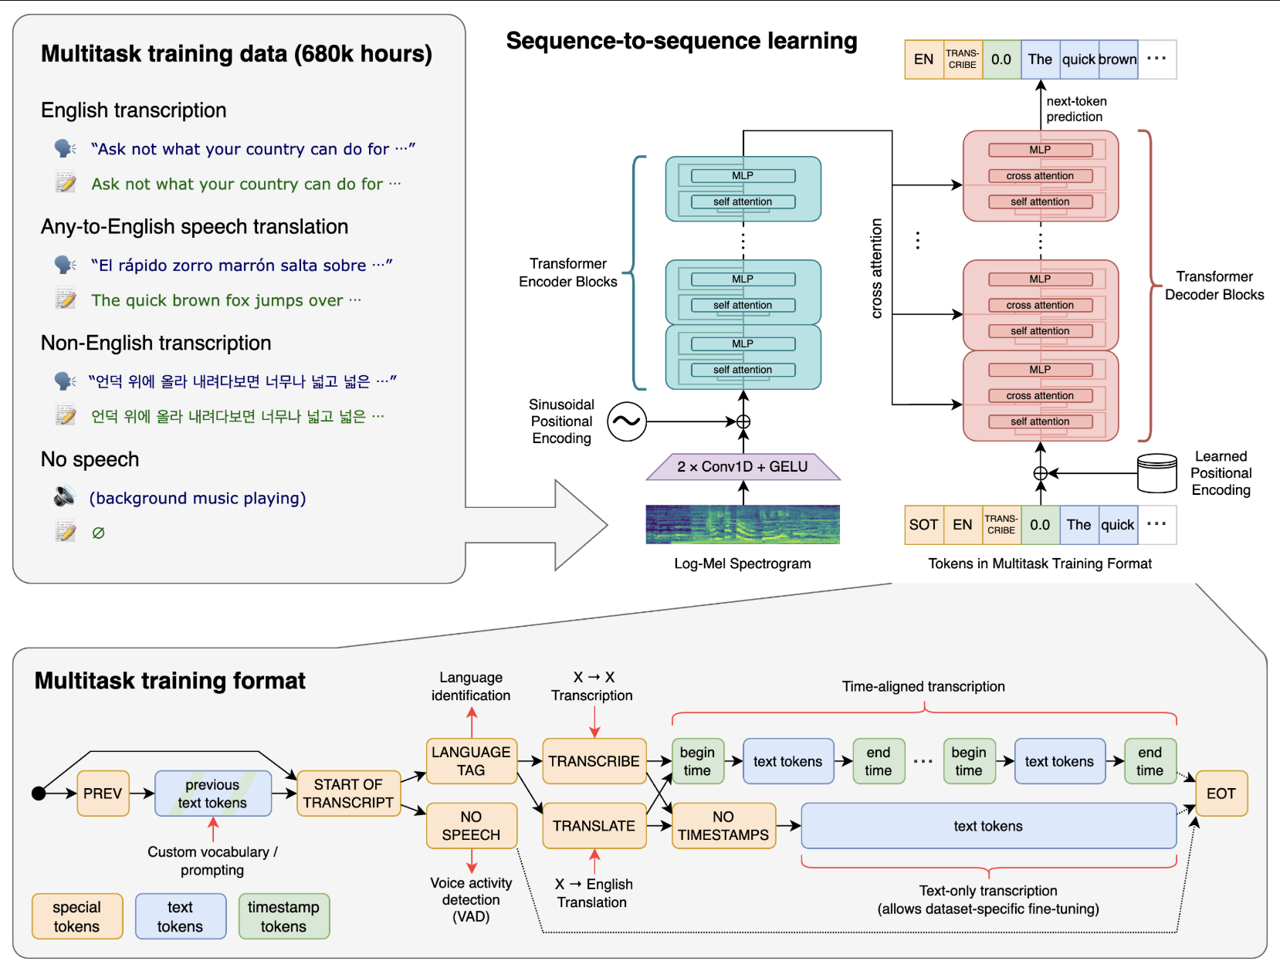
    - Six model sizes, four are English-only versions
    - Used for transcription, translation, and language detection
    - .en models for English-only tend to perform better
* **Part 3 - Avatar and Text-to-speech**
  + **Tools:** Elevenlabs, SadTalker, OBS
  + Generated questions are converted to human like speech
  + Animation of the avatar’s speech using SadTalker
  + Avatar interviewer streamed through OBS virtual cam
* Steps:
  + Create Conversational AI agent on ElevenLabs and generate API key for audio from LLM-generated questions
  + Feed the audio and interviewer image to SadTalker to generate animation
  + Route output video through OBS to create a live interviewer.x
* **Tools that can be used for candidate monitoring:** MediaPipe, OpenCV, YOLOv8
  + MediaPipe detects face and gaze direction
  + <https://github.com/Asadullah-Dal17/Eyes-Position-Estimator-Mediapipe>
  + YOLOv8 is used to identify distractions in the frame. Ex: phone
  + <https://yolov8.com/>
  + Distractions and gaze directions are logged into the system and used to evaluate the candidate